ASSIGNMENT-2 DOCKER-[FREESTYLE]
GITHUB

+--------------+--------------+
| | |
Q1 Repo Q2 Repo Q4 Repo
| | |
v v v
Q1-Freestyle Q2-Freestyle Q4-Freestyle
| | |
+--------------+--------------+
|
JENKINS
|
DOCKER
|
+---------+---------+
| | |
Q1 Q2 Q4
| | |
:81 :90 :8082

q1 0.0.0.0:80---81/tcp
q2 0.0.0.0:80---90/tcp
q4 0.0.0.0:8082---80/tcp

3)GIT REPO – 2026Q4BF
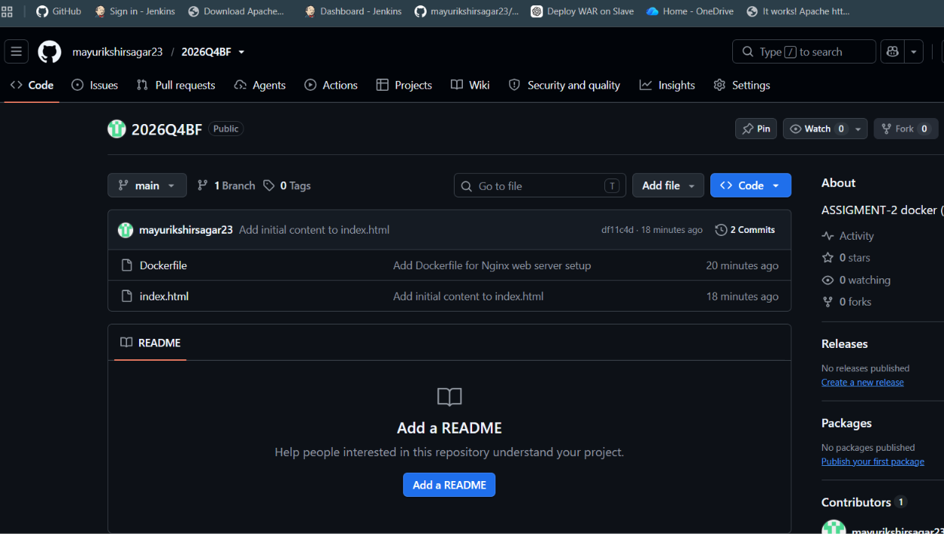
2)GIT REPO- DOCKERFILE AND HTML FILE
3)BUILD AND DEPLOY IN JENKINS FOR PORT 8082.
4) SERVICE --- Q4 , HOST PORT ---- 8082 , CONTAINER PORT --- 80
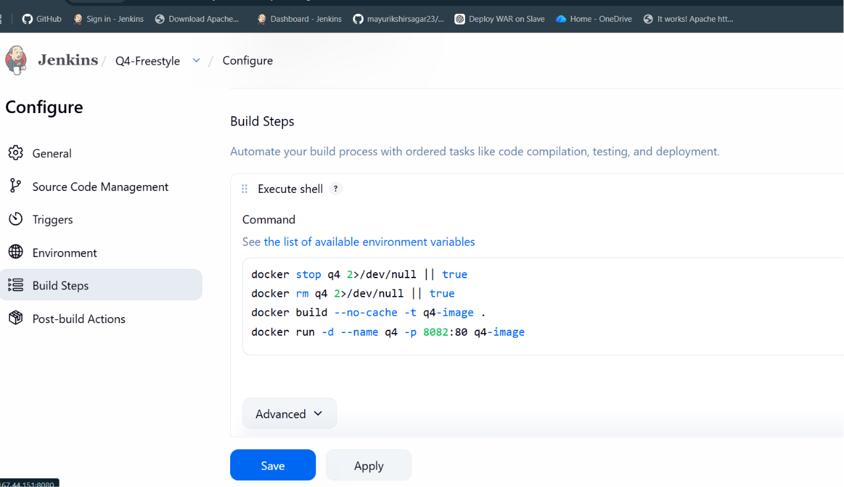
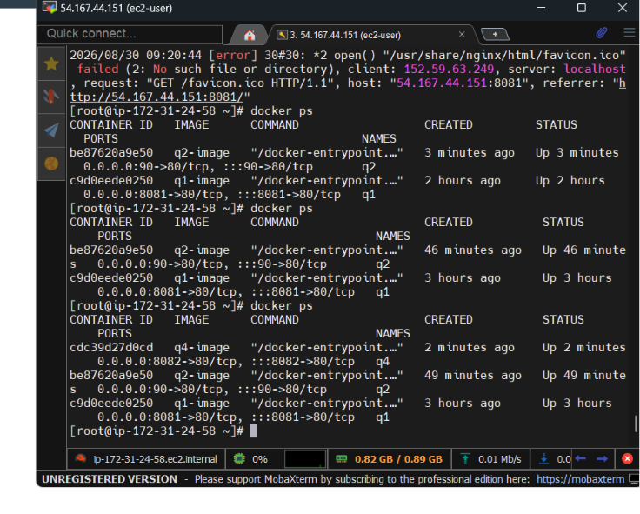
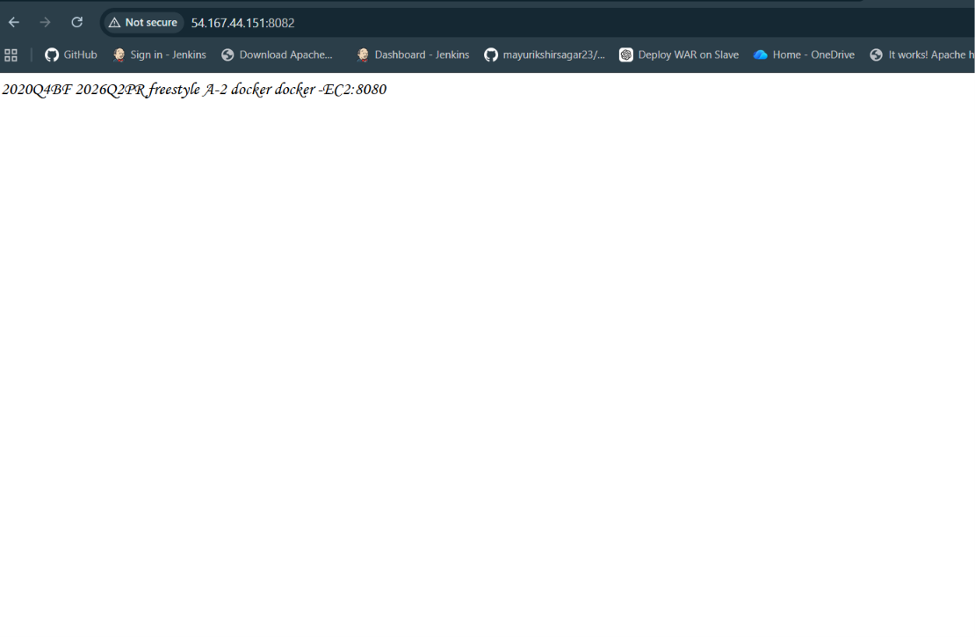
5) CHECK ON BROWSER------- http://EC2-IP -PUBLIC:82

6) CHECK THE PORT FOR EACH HOST AND CONTAINER
SERVICE HOSTPORT CONTAINER PORT
Q1 81 80
Q2 90 80
Q4 8082 80
JENKINS 8080 8080

